**Transitive and intransitive verbs**

**Transitive verbs:**

A verb which has **an object is** called transitive verb.

Or

A verb which takes **one or more object is** called transitive verb.

**Examples:**

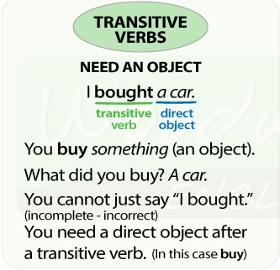

"We **watched** a **movie** last night."

"She's **making** promises."

"Santa **gave** me a present."

"He continuously **clicked** his pen and it was incredibly annoying to me."

“He **owns** three cars.”

“He is **eating** an Apple.”

**Intransitive verb:**

A verb which **doesn’t have an object** is called an intransitive verb.

Or

A verb which doesn’t allow **a direct object is** called an intransitive verb.

Examples:

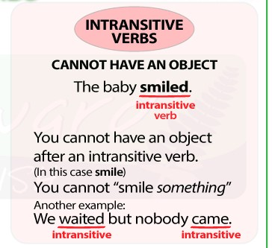

"River **flows**."

"I **sneezed**."

"My dog **ran**."

"Water **evaporates** when it's hot."

"You've **grown** since I last saw you!"

"I wonder how old I will be when I **die**."

**Some verbs can be either transitive or intransitive**

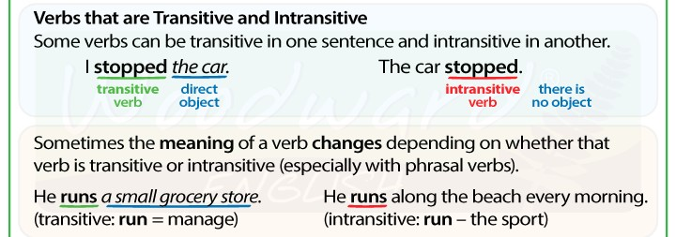

|  |  |
| --- | --- |
| **Transitive verb** | **Intransitive verb** |
| The pilot is **flying** a jet. | The eagle is **flying**. |
| Mr. Lee is **driving** his new car. | Mr. Lee is **driving** carefully. |
| The umpire **blew** the vessel to end the game. | The wind **blew** strongly**.** |
| They are **playing** cricket. | They are **playing.** |
| He **studied** medicine. | The students **studied** hard. |
| He **runs** his own company. | He **runs** very fast. |
| They tried hard but **lost** the competition. | They took part in the competition but **lost**. |

**Phrase:**

A **phrase** is any group of words, often carrying a special idiomatic meaning.

Or

A group of words which makes a sense by **does not convey a complete meaning.**

Or

A phrase is group of two or more words **functioning as a meaningful unit** within a sentences or a clause.

In phrase we don’t have a verb.

**Examples:**

By the way

In a minute

Straight away

Once more

In my opinion

In the garden

In the end

On the beach

At last

Once upon a time.

Over the moon

Here and there

**Clause:**

A clause is a group of words. It has a **subject and a verb.**

Some sentences consist of only one clause with a subject and verb. A sentences that consists of only one clause is called simple sentences.

Examples:

**Tom opened** the door for Mrs. Lee.

All the **children** **stood up**.

**Miss Lee went** to her desk.

**She** **called out** the names one by one.

**Everyone** **answered** except Peter.

**He had** a cold.

**Subordinate clause or dependent clause:**

**Some clauses contain a subject and verb**, but they do not make a sense by themselves. They are called subordinate clause.

Subordinate clause begins with words like: **When, if, because, who** and **which.** They depend on the **main clause to make sense.**

Examples:

**You may sit** **where ever you like.**

**Main clause** **subordinate clause**

**I have a watch which is also a calculator.**

**We will go out when the rain stops.**

**Do you know why she is crying?**

**You should stay at home if you are not well.**

**He was late because he missed the train.**

**This is the house that jack built.**

**Relative clause:**

A subordinate clause that describes a person or thing in the main clause is called a relative clause.

Relative clauses about people begins with relative pronouns **who, whom and whose**. These pronouns refer to person in the main clause.

**Examples:**

**Nobody likes people who are rude.**

**Is that the waitress who served us?**

**She has a pen friend to whom she writes every week.**

**Hands up all the children whose birthdays fall between January and June.**

Relative clause about things or animals begin with **which, that or whose**.These pronouns refer to thing or animal in the main clause.

**Examples:**

**Kamran has a watch** **that shows the date.**

**She bought a computer which was made in Japan.**

**We have written a new book whose aim is to make grammar interesting.**

**A mole is an animal that lives in a hole.**